**ListBox Control**

The ListBox represents a Windows control to display a list of items to a user. A user can select an item from the list. It allows the programmer to add items at design time by using the properties window or at the runtime.

Let's create a list box by dragging a ListBox control from the Toolbox and dropping it on the form.

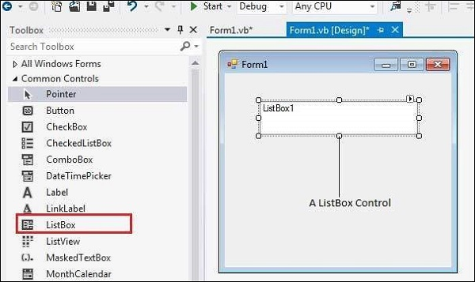

You can populate the list box items either from the properties window or at runtime. To add items to a ListBox, select the ListBox control and get to the properties window, for the properties of this control. Click the ellipses (...) button next to the Items property. This opens the String Collection Editor dialog box, where you can enter the values one at a line.

**Properties of the ListBox Control**

The following are some of the commonly used properties of the ListBox control

1. AllowSelection

Gets a value indicating whether the ListBox currently enables selection of list items.

2. BorderStyle

Gets or sets the type of border drawn around the list box.

3.ColumnWidth

Gets or sets the width of columns in a multicolumn list box.

4.HorizontalExtent

Gets or sets the horizontal scrolling area of a list box.

5.HorizontalScrollBar

Gets or sets the value indicating whether a horizontal scrollbar is displayed in the list box.

6.ItemHeight

Gets or sets the height of an item in the list box.

7.Items

Gets the items of the list box.

8.MultiColumn

Gets or sets a value indicating whether the list box supports multiple columns.

9.ScrollAlwaysVisible

Gets or sets a value indicating whether the vertical scroll bar is shown at all times.

10.SelectedIndex

Gets or sets the zero-based index of the currently selected item in a list box.

11.SelectedIndices

Gets a collection that contains the zero-based indexes of all currently selected items in the list box.

12.SelectedItem

Gets or sets the currently selected item in the list box.

13.SelectedItems

Gets a collection containing the currently selected items in the list box.

14.SelectedValue

Gets or sets the value of the member property specified by the ValueMember property.

15.SelectionMode

Gets or sets the method in which items are selected in the list box. This property has values −

None

One

MultiSimple

MultiExtended

16.Sorted

Gets or sets a value indicating whether the items in the list box are sorted alphabetically.

17.Text

Gets or searches for the text of the currently selected item in the list box.

18.TopIndex

Gets or sets the index of the first visible item of a list box.

**Events of the ListBox Control**

The following are some of the commonly used events of the ListBox control −

1.Click

Occurs when a list box is selected.

2.SelectedIndexChanged

Occurs when the SelectedIndex property of a list box is changed.

**Example 1**

In the following example, let us add a list box at design time and add items on it at runtime.

Take the following steps −

Drag and drop two labels, a button and a ListBox control on the form.

Set the Text property of the first label to provide the caption "Choose your favourite destination for higher studies".

Set the Text property of the second label to provide the caption "Destination". The text on this label will change at runtime when the user selects an item on the list.

Click the listbox and the button controls to add the following codes in the code editor

Public Class Form1

Private Sub Form1_Load(sender As Object, e As EventArgs) Handles MyBase.Load

' Set the caption bar text of the form.

Me.Text = "List Box Control"

ListBox1.Items.Add("Canada")

ListBox1.Items.Add("USA")

ListBox1.Items.Add("UK")

ListBox1.Items.Add("Japan")

ListBox1.Items.Add("Russia")

ListBox1.Items.Add("China")

ListBox1.Items.Add("India")

End Sub

Private Sub Button1_Click(sender As Object, e As EventArgs) Handles Button1.Click

MsgBox("You have selected " + ListBox1.SelectedItem.ToString())

End Sub

Private Sub ListBox1_SelectedIndexChanged(sender As Object, e As EventArgs)

Handles ListBox1.SelectedIndexChanged

Label2.Text = ListBox1.SelectedItem.ToString()

End Sub

End Class

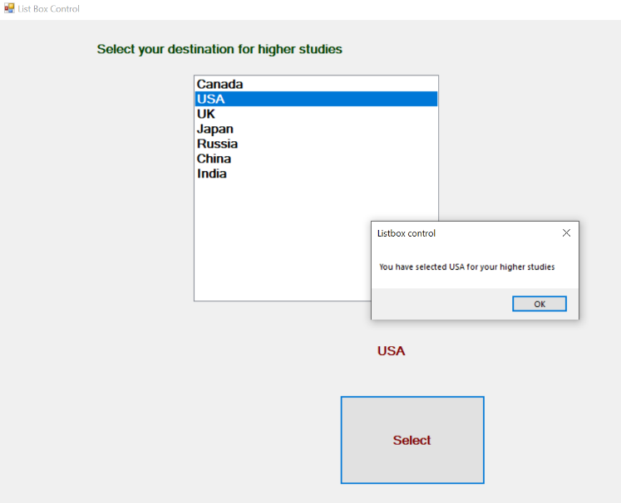

**Example 2**

In this example, we will fill up a list box with items, retrieve the total number of items in the list box, sort the list box, remove some items and clear the entire list box.

Design the Form

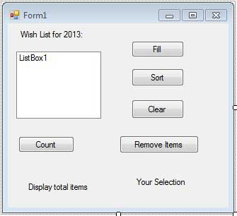

Add the following code in the code editor window

Public Class Form1

Private Sub Form1_Load(sender As Object, e As EventArgs) Handles MyBase.Load

' Set the caption bar text of the form.

Me.Text = "ListBox Control"

' creating multi-column and multiselect list box

ListBox1.MultiColumn = True

ListBox1.SelectionMode = SelectionMode.MultiExtended

End Sub

'populates the list

Private Sub Button1_Click_1(sender As Object, e As EventArgs) Handles Button1.Click

ListBox1.Items.Add("Safety")

ListBox1.Items.Add("Security")

ListBox1.Items.Add("Governance")

ListBox1.Items.Add("Good Music")

ListBox1.Items.Add("Good Movies")

ListBox1.Items.Add("Good Books")

ListBox1.Items.Add("Education")

ListBox1.Items.Add("Roads")

ListBox1.Items.Add("Health")

ListBox1.Items.Add("Food for all")

ListBox1.Items.Add("Shelter for all")

ListBox1.Items.Add("Industrialisation")

ListBox1.Items.Add("Peace")

ListBox1.Items.Add("Liberty")

ListBox1.Items.Add("Freedom of Speech")

End Sub

'sorting the list

Private Sub Button2_Click(sender As Object, e As EventArgs) _ Handles Button2.Click

ListBox1.Sorted = True

End Sub

'clears the list

Private Sub Button3_Click(sender As Object, e As EventArgs) _ Handles Button3.Click

ListBox1.Items.Clear()

End Sub

'removing the selected item

Private Sub Button4_Click(sender As Object, e As EventArgs) _ Handles Button4.Click

ListBox1.Items.Remove(ListBox1.SelectedItem.ToString)

End Sub

'counting the numer of items

Private Sub Button5_Click(sender As Object, e As EventArgs) _ Handles Button5.Click

Label1.Text = ListBox1.Items.Count

End Sub

'displaying the selected item on the third label

Private Sub ListBox1_SelectedIndexChanged(sender As Object, e As EventArgs) Handles ListBox1.SelectedIndexChanged

Label3.Text = ListBox1.SelectedItem.ToString()

End Sub

End Class

